**SRM Institute of Science and Technology**

**Department of Computing Technologies**

21CSS101J PROGRAMMING FOR PROBLEM-SOLVING

**LLJ2 – REFUTE QUESTIONS**



**A REFUTE QUESTION REPORT – C**

**Submitted by**

**OVIYA.B**

**Registration Number: RA2411030010004**

FACTORIAL ©

***DESCRIPTION*** Given an input, the task is to find factorial of the given number.

Factorial of a number is given by the product of the integers from 1 to (n-1)

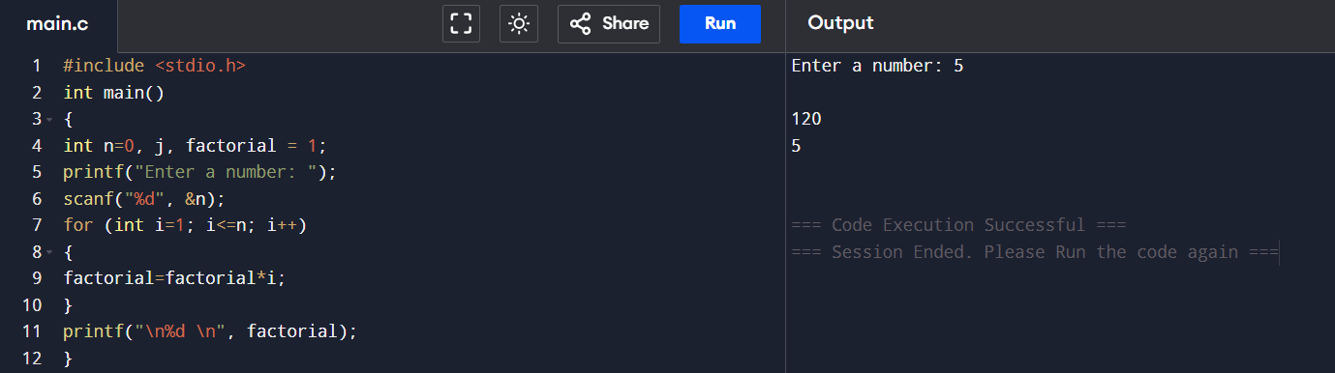

**Output:**

* Input = 5 , output=120

**Refute Test Case:** The number -1.

* **Expected Output:** The number -1 is complex number.
* **Actual Output (Current Code):** 1

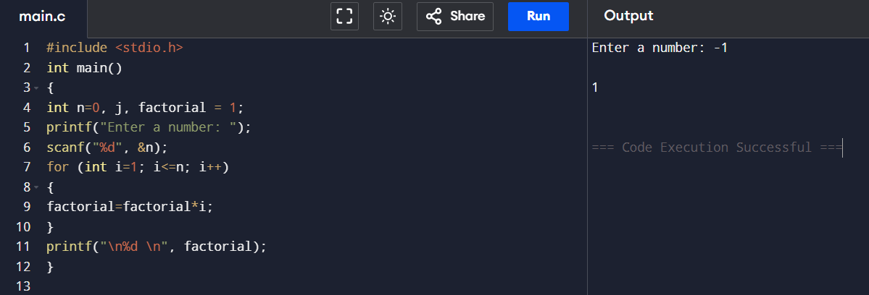

**Why the code fails for -1:** The factorial of negative numbers will be complex. This code does not check for any special conditions for numbers less than 0, thus the code runs negative numbers like any other positive number.

***PROGRAM CODE***

#include <stdio.h>

int main()

{

int n=0, j, factorial = 1;

printf("Enter a number: ");

scanf("%d", &n);

for (int i=1; i<=n; i++)

{

factorial=factorial*i;

}

printf("\n%d \n", factorial);

}

LEAP YEAR ©

***DESCRIPTION:*** Write a program to determine whether a given integer is **even** or **odd**. An even number is divisible by 2 (i.e., it has a remainder of 0 when divided by 2), and an odd number has a remainder of 1 when divided by 2.

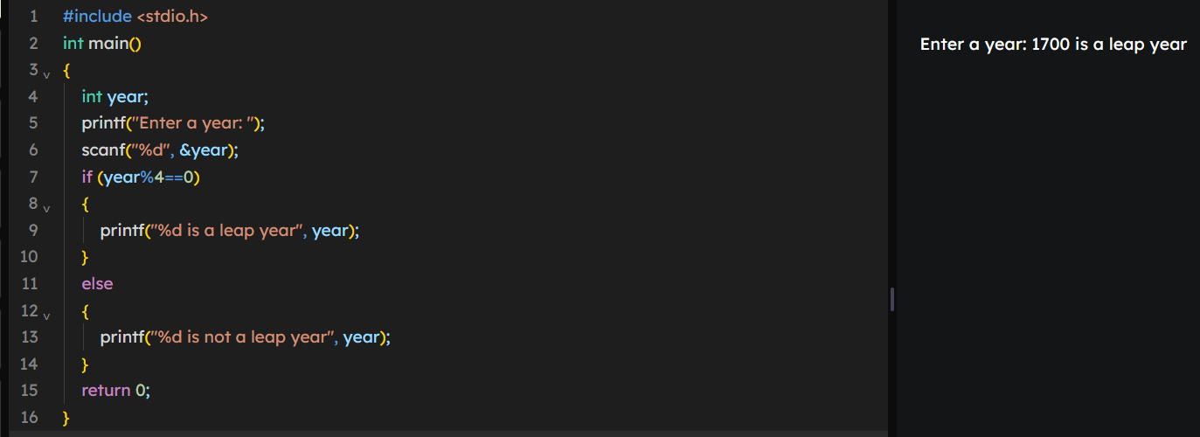

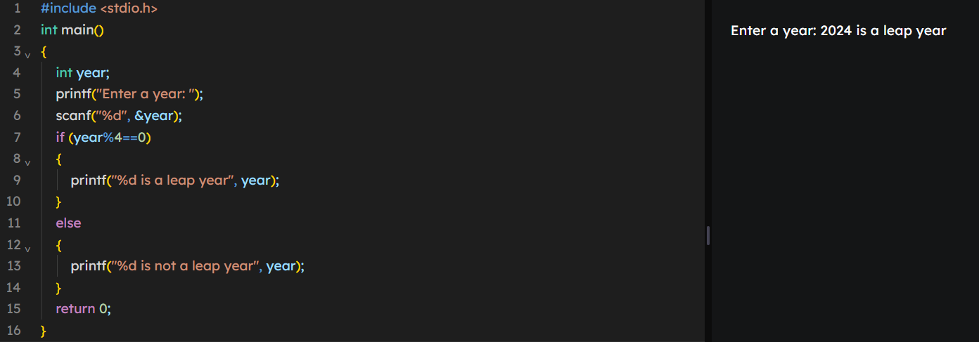

**Output:**

* Correct test case: Input = 2024, Output = 2024 Is a leap year

**Refute Test Case:** The year 1700.

* **Expected Output:** The year 1700 is not leap year.
* **Actual Output (Current Code):** The year 1700 is a leap year

**Explanation:** Years divisible by 100 should also be divisible by 400 but in this case this code doesn’t check for that condition. Thus 1700 is shown as leap year

***PROGRAM CODE:***

***#include <stdio.h>***

***int main()***

***{***

***int year;***

***printf("Enter a year: ");***

***scanf("%d", &year);***

***if (year%4==0)***

***{***

***printf("%d is a leap year", year);***

***}***

***else***

***{***

***printf("%d is not a leap year", year);***

***}***

***return 0;***

***}}***